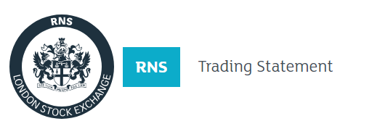
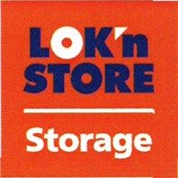
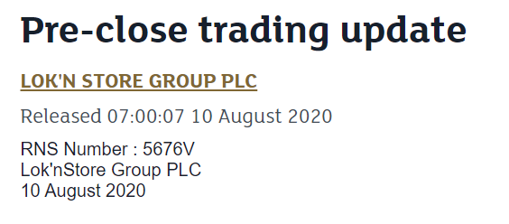

Lok'nStore Group plc
("Lok'nStore", the "Company", "We" or the "Group")
Pre-close trading update
"Robust trading in FY2020 with good progress made on development pipeline"
Lok'nStore, the fast-growing AIM listed self-storage company, is pleased to provide the following update on trading in the financial year to 31 July 2020.
Trading was strong with self-storage revenue up 6.3%. At 31 July 2020 occupancy was up 5.9% and price per let sq. ft. was slightly down 0.3% compared to the same date twelve months ago. Following more subdued trading during the full lock-down, May, June and July have been stronger with new enquiries and move-ins at an all-time high in July.
We opened two new stores in Oldbury and Gloucester in the year and our new landmark store in Leicester on 1st August 2020 immediately after the period end. Early trading at all three stores has been encouraging.
Recently we received planning consent at our new Salford site. We will commence the renovation and fitting out of this 50,000 sq. ft store shortly and expect it to be open in early 2021. We have also exchanged contracts, subject to planning, on a new site in Kettering, Northamptonshire, which will be developed into a 40,000 sq. ft landmark store.
In July, we announced a one-year extension of our existing £75 million bank facility which now runs until April 2025. The facility also allows for a further one-year extension and contains a £25 million accordion option to facilitate the Group's future growth. Our current pro forma loan to value ratio is 19.8% net of cash with a pro forma cash position of £12.8 million.
Preliminary results will be announced on Monday 2 November 2020.
Andrew Jacobs, Chairman of Lok'nStore said:
"Against the current unsettled economic circumstances Lok'nStore's trading remains resilient with 6.3% growth in self-storage revenue and occupancy up 5.9%. We continue to execute our objective to open more landmark stores whilst remaining conservatively geared with landmark stores in Gloucester, Oldbury and Leicester now open and the Salford store due to open early next year.
With our modest gearing, valuable property assets and strong and growing cash flow the Group will continue to execute its current growth strategy as the economy returns to normal. The strong pipeline of new stores will add considerable momentum to sales and earnings growth over the medium term allowing further increases in dividends."

-Ends-
Enquiries:
Lok'nStore Andrew Jacobs, CEO
Ray Davies, Finance Director 01252 521 010
finnCap Julian Blunt, Giles Rolls, Corporate Finance
Alice Lane, Corporate Broking
020 7220 0500
Camarco Billy Clegg / Tom Huddart
0203 757 4983

