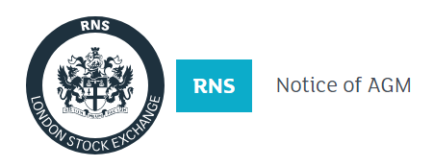
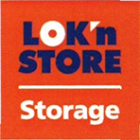
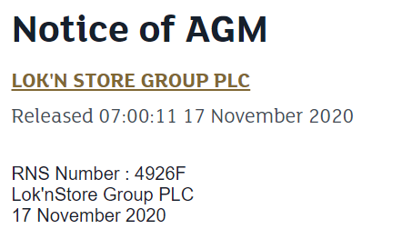
Lok’nStore Group plc
(“Lok’nStore” or the “Company”)
Posting of Notice of Annual General Meeting (“AGM”) and Annual Report and Accounts
Lok’nStore announces that the 2020 Annual Report and Accounts and Notice of AGM were posted to shareholders on 17 November 2020. Copies are available at the investor section of the Company’s website at www.loknstore.co.uk.
The AGM will be held as a closed meeting at 4.30 pm on 10 December 2020 (see below).
Important Information Regarding Annual General Meeting
The continuing Coronavirus pandemic has led to the imposition of severe restrictions on public gatherings. As a consequence, we are making changes to the way in which we conduct this year’s AGM. The Company understands and respects the importance of the AGM to Shareholders and the Board greatly values the opportunity to meet Shareholders in person. However, the health and safety of our Shareholders, employees and the broader community is of paramount importance.
In light of the UK Government’s current guidance on public gatherings, and the new regulations set out in Schedule 14 of the Corporate Insolvency and Governance Act, the Board has concluded that Shareholders will not be permitted to attend the AGM in person this year and this year’s AGM will be run as a closed meeting. Only a small number of Directors will be permitted to attend the AGM to satisfy the minimum quorum requirements as stated in the Company’s Articles of Association. The format of the meeting will be purely functional.
All other Shareholders should not attempt to attend the AGM in person.
Shareholders are strongly encouraged to appoint the Chairman of the meeting as their proxy. Under the Government restrictions, if a Shareholder appoints someone else as their proxy, that proxy will not be able to attend the meeting in order to cast the Shareholder’s vote. Therefore, the appointment of any person other than the Chairman of the meeting would result in your votes not being cast.
The Board will continue to monitor the evolving impact of the pandemic and, if it becomes appropriate or necessary to make changes to the proposed format of the 2020 AGM, will inform Shareholders as soon as possible.
-ENDS-
Enquiries:
Lok’nStore  Andrew Jacobs, CEO  Ray Davies, Finance Director | 01252 521 010
finnCap Ltd  Julian Blunt/Giles Rolls, Corporate Finance  Alice Lane, ECM | 020 7220 0500
Camarco  Billy Clegg/Tom Huddart | 0203 757 4980

