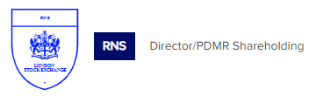
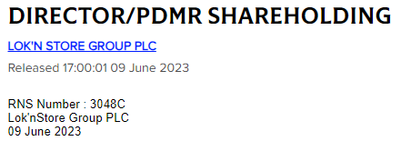

Lok'nStore Group plc
('Lok'nStore' or the 'Company')

Director/PDMR Shareholding
The Company was notified on 9 June 2023 that Neil Newman-Shepherd, Group Managing Director, had exercised options over 2,420 ordinary shares of 1p each ("Ordinary Shares") ("Exercise") and subsequently sold 2,420 Ordinary Shares at a price of 894.76 pence per Ordinary Share.

As a result of this transaction, Neil Newman-Shepherd's beneficial interest in the Company remains unchanged 30,739 Ordinary Shares representing 0.10 per cent of the Company's total voting rights.

Following the Exercise, the issued share capital of the Company is 30,084,719 Ordinary Shares of 1 pence each. There are no shares held in treasury and thus the total number of voting rights in the Company is 30,084,719 which may be used by shareholders as the denominator for the calculations by which they will determine if they are required to notify their interest in, or a change to their interest in, the Company under the FCA's Disclosure Guidance and Transparency Rules.

-Ends-

Enquiries:

Lok'nStore  Suzy Wolfe, Assistant Company Secretary | 01252 521 010
finnCap Ltd  Julian Blunt/Seamus Fricker, Corporate Finance  Alice Lane, ECM | 020 7220 0500
Peel Hunt LLP  Capel Irwin/Carl Hough/Henry Nicholls | 020 7418 8900
Camarco  Billy Clegg/Tom Huddart/Oliver Head | 0203 757 4980

The Notification of Dealing Form set out below is provided in accordance with the requirements of the EU Market Abuse Regulation.

1. | Details of the person discharging managerial responsibilities / person closely associated
a) | Name | Neil Newman-Shepherd
2. | Reason for the Notification
a) | Position/status | Group Managing Director
b) | Initial notification/Amendment | Initial notification
3. | Details of the issuer, emission allowance market participant, auction platform, auctioneer or auction monitor
a) | Name | Lok'nStore Group plc
b) | LEI | 213800MXVAMG3CA42A19
4. | Details of the transaction(s): section to be repeated for (i) each type of instrument; (ii) each type of transaction; (iii) each date; and (iv) each place where transactions have been conducted
a) | Description of the Financial instrument, type of instrument | Ordinary shares of 1p each
 | Identification code | GB0007276115
b) | Nature of the transaction | Exercise and sale of Ordinary Shares
c) | Price(s) and volume(s) | No. of Shares Price  2,420 894.76p
d) | Aggregated information:  • Aggregated volume  • Price | See above
e) | Date of the transaction | 9 June 2023
f) | Place of the transaction | London Stock Exchange, AIM Market (XLON)

