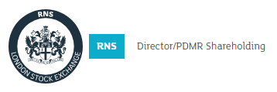
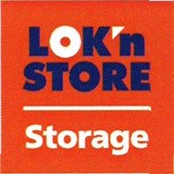

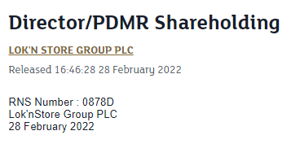

Lok'nStore Group plc
('Lok'nStore' or the 'Company')

Director/PDMR Shareholding

The Company was notified today that on the 24 February 2022, Richard Holmes, Non-Executive Director, purchased 2,000 ordinary shares of 1p each ("Ordinary Shares") at a price of 986 pence per Ordinary Share.

As a result of this transaction, Richard Holmes’ beneficial interest in the Company is 289,606 Ordinary Shares representing 0.97 percent of the Company's total voting rights.

-Ends-

Enquiries:

Lok'nStore  Suzy Wolfe, Assistant Company Secretary | 01252 521 010
finnCap Ltd  Julian Blunt/Seamus Fricker, Corporate Finance  Alice Lane, ECM | 020 7220 0500
Peel Hunt LLP  Capel Irwin/Carl Hough/Henry Nicholls | 020 7418 8900
Camarco  Billy Clegg/Tom Huddart/Oliver Head | 0203 757 4980

The Notification of Dealing Form set out below is provided in accordance with the requirements of the EU Market Abuse Regulation.

 | Details of the person discharging managerial responsibilities / person closely associated
a) | Name | Richard Holmes
 | Reason for the Notification
a) | Position/status | Non-Executive Director
b) | Initial notification/Amendment | Initial notification
 | Details of the issuer, emission allowance market participant, auction platform, auctioneer or auction monitor
a) | Name | Lok'nStore Group plc
b) | LEI | 213800MXVAMG3CA42A19
 | Details of the transaction(s): section to be repeated for (i) each type of instrument; (ii) each type of transaction; (iii) each date; and (iv) each place where transactions have been conducted
a) | Description of the Financial instrument, type of instrument | Ordinary shares of 1p each
 | Identification code | GB0007276115
b) | Nature of the transaction | Purchase of Ordinary Shares
c) | Price(s) and volume(s) | No. of Shares Price  2,000 986p
d) | Aggregated information:  - Aggregated volume  - Price | See above
e) | Date of the transaction | 24th February 2022
f) | Place of the transaction | London Stock Exchange, AIM Market (XLON)

