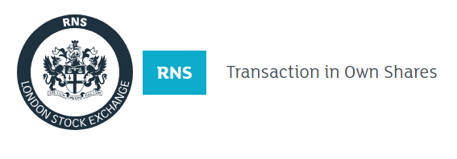
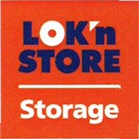

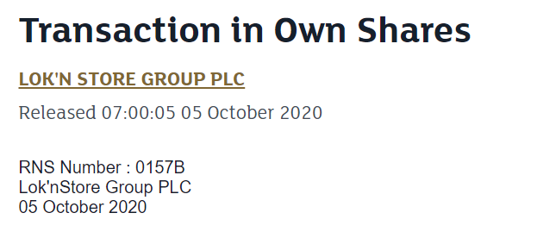

Lok'nStore Group plc
('Lok'nStore' or the 'Company')

Transaction in Own Shares

Lok'nStore, the fast-growing AIM listed self-storage company, announces that on 2 October 2020 it bought back 29,972 ordinary shares of 1p each ("Ordinary Shares") in the market at a price of 517.5 pence per Ordinary Share ("Buy-back"). The Ordinary Shares acquired will be held in treasury.

Following the Buyback, the issued share capital of the Company is 29,641,559 Ordinary Shares of which 37,972 Ordinary Shares are held in treasury. The total number of voting rights in the Company, excluding Treasury shares will therefore be 29,603,587 (the 'Figure').

The Figure may be used by shareholders as the denominator for the calculations by which they will determine if they are required to notify their interest in, or a change to their interest in the Company under the FCA's Disclosure Guidance and Transparency Rules.

-Ends-

Enquiries:

Lok'nStore  Suzy Wolfe, Assistant Company Secretary | 01252 521 010
finnCap Ltd  Julian Blunt/Giles Rolls, Corporate Finance  Alice Lane, ECM | 020 7220 0500
Camarco  Billy Clegg/Tom Huddart/Oliver Head | 0203 757 4980

